8 October 2020

Lab 5

1. 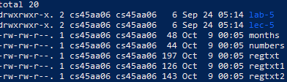
2. $sort -n months
3. $sort -m months numbers >‘monbrs’
4. $grep ‘^r’ /etc/passwd
5. $grep -c ‘^r’ /etc/passwd
6. $grep -v ‘cs45’ /etc/passwd
7. $grep ‘y$’ /etc/passwd
8. $grep -i ‘root\|ly\|body’ /etc/passwd
9. $cat -t regtxt
10. $grep '\(([0-9]\{3\})\|[0-9]\{3\}\)[ -]\?[0-9]\{3\}[ -]\?[0-9]\{4\}' regtxt
11. aaaaaAA
12. $sed 's/(^|[^-0-9])[0-9]{3}-[0-9]{2}-[0-9]{4}([^-0-9]|$)/\\*\\*\\*$/g' regtxt2
13. $sed 's/100\+/(&)/g' regtxt1
14. $grep '\(([0-9]\{3\})\|[0-9]\{3\}\)[ -]\?[0-9]\{3\}[ -]\?[0-9]\{4\}' regtxt2
15. $sed 's/\(([0-9]\{3\})\|[0-9]\{3\}\)[ -]\?[0-9]\{3\}[ -]\?[0-9]\{4\}/\5\2\3\1/' regtxt2